Ta Quang Tung – 104222196

COS20019 – Cloud Computing Architecture - Wk4: ACF Lab 4: Working with EBS

Task 1 - Create a New EBS Volume

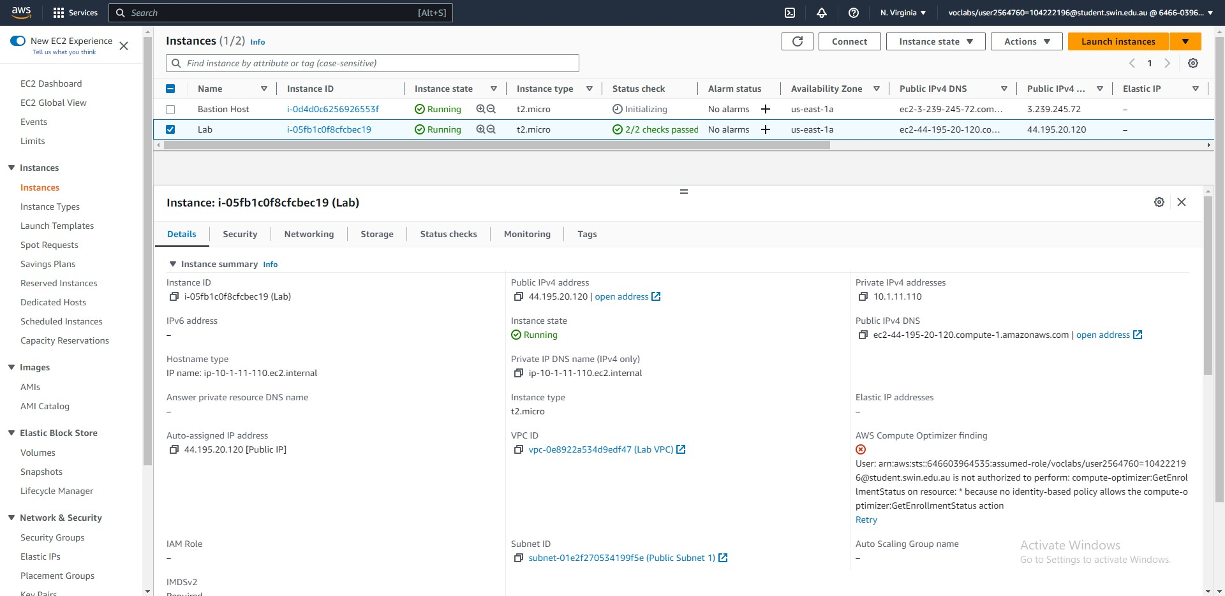



Steps 5-7: The Lab EC2 instance running in Availability Zone us-east-1a.



Step 8: An EBS volume has been set up by the lab and attached to the Lab instance.



Steps 9-10: Setting up a new EBS volume with the required settings: type General Purpose SSD, size 1GiB, availability zone us-east-1a, and name of My Volume.

Task 2 - Attach the Volume to an Instance



Steps 11-14: Attach the newly created volume to the Lab instance.

Task 3 - Connect to Your Amazon EC2 Instance



Steps 15-18: Set seconds between keepalives to 30.



Step 19: Set the host name to the public DNS of the Lab instance.



Step 19 (continued): Use the ppk key file to access the instance.



Steps 20-21: Log into the instance as ec2-user.

Task 4 - Create and Configure Your File System



Step 30: View the storage available on the instance.



Steps 31-33: Create a new file system on the volume, create a directory for mouting the volume, and mount the volume.



Step 34: View the configuration file.



Step 35: View the storage again. A new line /dev/xvdf correctly shows.



Steps 36-37: Add a text file to the mounted volume and verify it is created.

Task 5 - Create an Amazon EBS Snapshot



Steps 38-40: Create a snapshot of the EBS volume.



Step 41: The snapshot has been created and is available.



Steps 42-43: Delete the previous text file.

Task 6: Restore the Amazon EBS Snapshot



Steps 44-47: Create a new volume out of the snapshot in the same Availability Zone as the old volume.



Steps 48-52: Attach the new volume to the Lab instance.



Steps 53-55: Create a new directory to mount the new volume, mount the volume, and verify that the old text file exists.